31.11: a) If 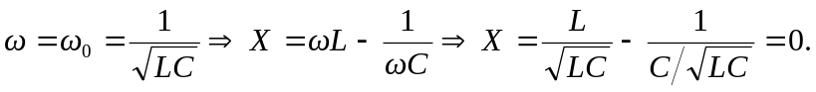
b) When 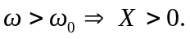
c) When 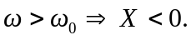
d) The graph of X against is on the following page.

